Experience joining technology 4.0 live at the SCHWEISSEN 2019 trade fair
EWM AG presents the future of welding technology

Germany’s largest manufacturer and world-leading provider for arc welding technology will be at this year’s SCHWEISSEN trade fair in Linz. EWM AG will be at stand 221 at the Design Center from 10–12 September to present its innovative welding technology solutions. EWM will showcase the new Titan XQ 400 AC puls for the first time ever. This specialised aluminium welding machine represents a quantum leap in the world of welding technology, making it easier and safer to weld even extremely thin sheets. Trade fair goers will also get the chance to see the various high-performance, energy-efficient, low-emission welding machines on offer by EWM.

In addition to the Titan XQ 400 AC puls, EWM products on display at SCHWEISSEN will include the decompact Titan XQ puls and the compact Titan XQ puls C. The compact multiprocess MIG/MAG welding machine is available in 350 A or 400 A versions. With an action radius of up to 30 metres, this machine is not only suitable for welding booths in industry, trade and training sectors, it can also be used for working with larger components. With the Taurus steel series, EWM is focussing on the area of professional and highly efficient MAG welding of low-alloy steel with solid or flux cored wire. All machines and controls feature simple operation of all the required functions. With its innovative welding 4.0 ewm Xnet 2.0 welding management system, EWM has applied the added value of Industry 4.0 to welding production. By digitally linking planning, controlling and production operations, the modular software opens up many new opportunities for companies of all sizes to enhance their efficiency. ewm Xnet 2.0 helps to future-proof welding companies. Users benefit from increased productivity, reduced costs and quality assurance.

EWM presence in Austria
Beyond taking part in the SCHWEISSEN 2019 trade fair, EWM has enjoyed a strong presence in Austria in recent years. In the Austrian town of Eberstalzell, EWM AG has a skills centre, roughly 2,000 square metres in size, for all matters related to arc welding. With the move to the new building right on the A1 motorway, the welding technology manufacturer, which has been active in the alpine republic for more than 30 years, has established a basis for further sustainable growth in Austria, despite strong competition.

Further information can be found on the EWM trade fair website at https://messe.ewm-group.com/linz/index_en.html

Date: 13 June 2019
Size: 2,622 characters including spaces
Figures: 5 (Source: EWM)

Fig. 1.
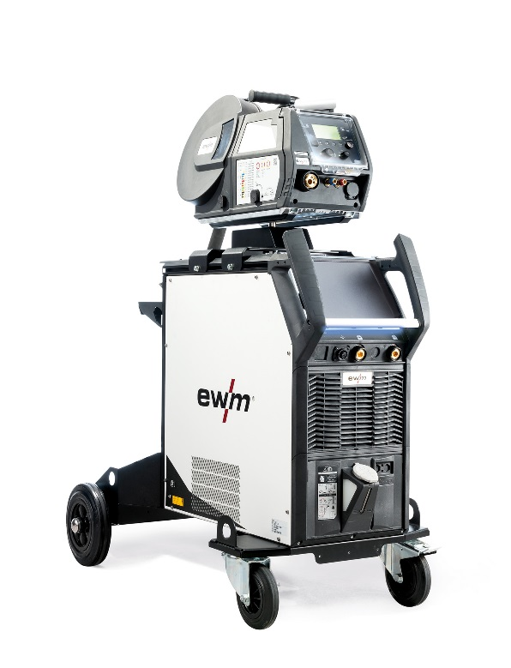
The Titan XQ 400 AC puls makes welding even thin aluminium sheets easy and safe.

Fig. 2.
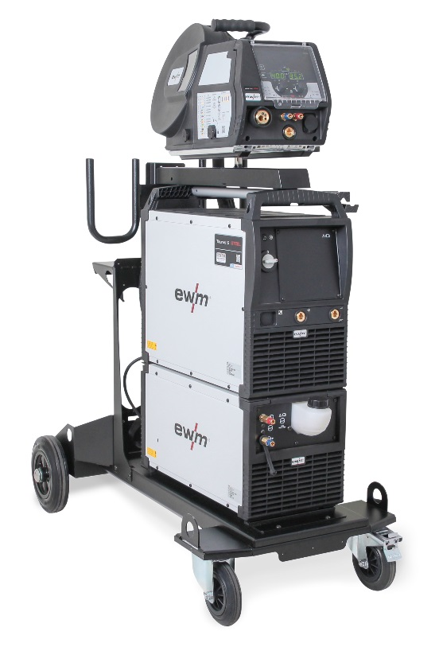
With its practically spatter-free pulsed arc, the Taurus Steel puls with drive 4X minimises rework.

Fig. 3.

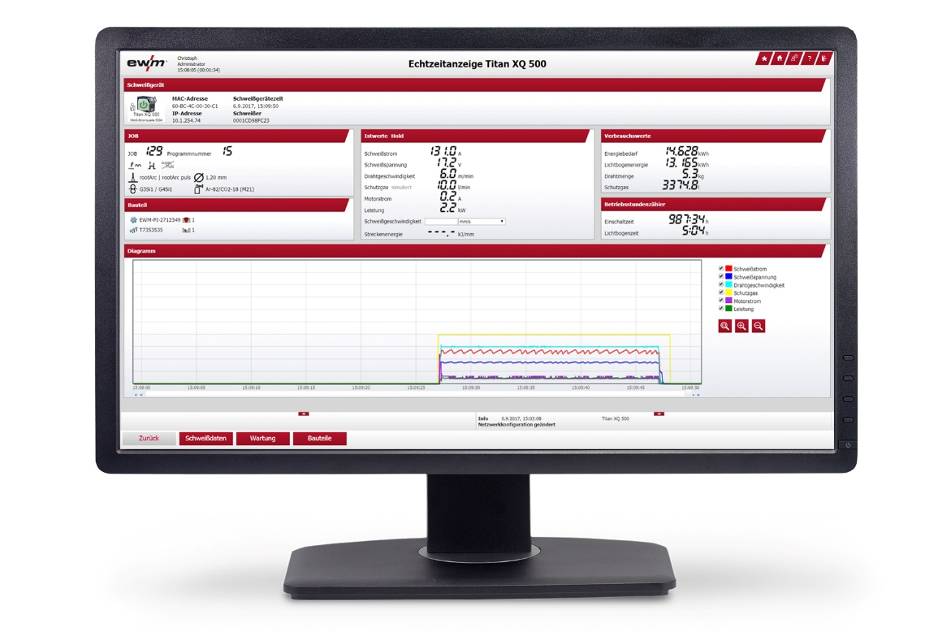
ewm Xnet 2.0 helps to effectively streamline production processes, increase their efficiency and meet obligatory documentation requirements quickly and in compliance with the applicable standards.
Fig. 4.

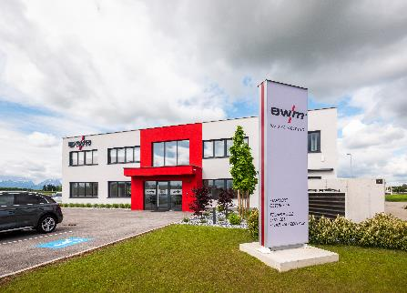
EWM AG has recently moved to its new location in Eberstalzell. As well as being home to the Sales, Consultancy and Service departments, the new location gives anyone interested the chance to experience the welding machines first-hand with on-site demonstrations.

Fig. 5.
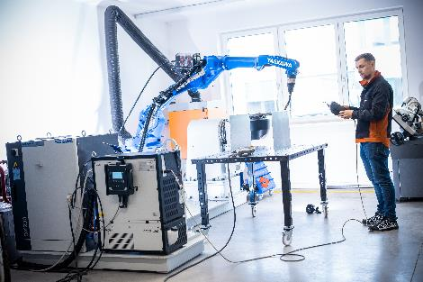
Automation plays a very important role in further development at EWM.

About EWM:
EWM AG is Germany’s largest and one of the most important worldwide manufacturers of arc welding technology. The family-run company from Mündersbach has been living its motto, “WE ARE WELDING”, with a great deal of passion for over 60 years, providing forward-looking and sustainable complete solutions for both industrial clients and craft businesses.
EWM develops high-end welding technology. The company, based in Germany’s Westerwald region, offers complete systems that cover everything from high-quality welding machines (and all associated components) to welding torches, welding consumables and accessories for manual and automated applications.
Users praise the products’ ease of operation and excellent results. Companies value the solid consultancy, service and enormous savings that come with EWM systems. The welding processes, some of which are patented, reduce the consumption of materials, energy and time during operation, and produce up to 75 per cent fewer welding fume emissions.
The innovative welding technology manufacturer currently employs around 800 employees at 14 German and 7 international locations, with just under 400 based at its original headquarters in Mündersbach.

EWM AG company contact
Maja Wagener
Dr.-Günter-Henle-Str. 8
56271 Mündersbach, Germany
Telephone: +49 2680 181-434
Email: maja.wagener@ewm-group.com
Internet: www.ewm-group.com

Press contact
Jan Leins
additiv pr GmbH & Co. KG
Public relations for logistics, steel, industrial goods and IT
Herzog-Adolf-Straße 3
56410 Montabaur, Germany
Telephone: +49 2602 950 99-16
Email: jl@additiv-pr.de
Internet: www.additiv-pr.de

